**Project Design Phase-II**

**Data Flow Diagram & User Stories**

| Date | 21/10/23 |
| --- | --- |
| Team ID | Team-591521 |
| Project Name | Project - 2.7 |
| Maximum Marks | 4 Marks |

**Data Flow Diagram**

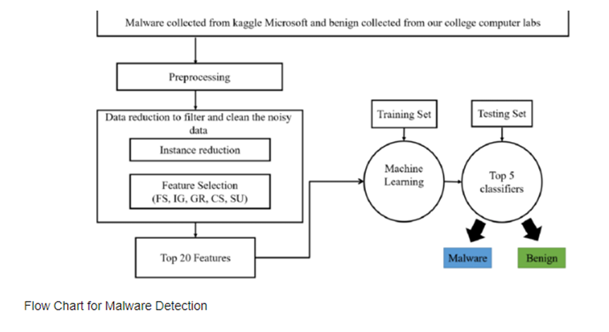

User Stories:

1. It is easier to use the code which can detect the malware.
2. Increasing Cyber Attacks has raised the concern over internet security.